CMP2806M Module

Scalable Database Systems

Assignment 1

Alexandre Barlaam

19695898

Contents

Database Design & ER Diagram 1

Queries 2

# Database Design & ER Diagram

When designing a database for the problem that was supplied to me, I started by considering how many tables was needed. To achieve this, I went through the brief and started to dissect it apart and sort the words into categories. The first category was entities. This contained the words drivers, vehicles, working day , parcels and GPS Co-ordinates. This meant that I needed 5 tables. These were Drivers containing all the information about the drivers, Vehicles containing information about the vehicles used by the company, Shifts which specified the days of the shifts as well as whether they were morning or afternoon shifts, the driver assigned to the shift and lastly which vehicle was assigned to this shift, Parcels specifying the number of parcel delivered as well as the driver and tracking which tracks each driver. I then realised that the shift table did not comply with second normal from. It was decided to split this table into two tables. Shift days containing the days of the shifts, and whether they were morning shifts or afternoon shifts. While the table Shifts became a link table specifying which driver and which vehicle was assigned to which shift. This meant that my final number of tables was 6.

The next category was attributes which was used to decide how many columns each table was required to have. The first table, drivers, was required to have information about the drivers therefore the attributes were their name, address as well as their phone number so they can be contacted easily. An ID was also part of the attributes for this table to be able to refer to each driver. The second table, Vehicles, needed to identify the type of vehicles and its registrations. The attributes would be the make of the vehicle, its model and registration to recognise each vehicle individually if they are of the same make and model. Lastly, an ID was also required. The third table, Shifts Days, was required to outline the days and times of the shifts. This was achieved by having three attributes. These were the days of the week as well as a morning and afternoon columns which were both defined as Booleans and an ID. The fourth table being shifts was made as a link table. Its attributes were the ID of the three previous tables which means they were the ID of shift days, the driver ID and the vehicle ID. The tracking table was designed with 5 attributes. These were a latitude as well as a longitude which were converted form the GPS coordinates as well as the nearest town that these coordinates correspond to. The next attribute was the driver that was driving the vehicle at the time of recording in the shape of his ID as well as an ID to be able to refer to each row of the table easily if needed. The last table, Parcels, only needed two attributes. The driver ID as well as how many parcels have been delivered by that driver in a day.

In terms of the keys used in each table. The entity drivers and vehicles has only a primary key being DID and VID respectively. Shift Days also had just one key being SDID as well as. For each of those entities, they had no foreign keys. The entity shifts had the most keys with 3. These were all foreign keys as it was a link table and were as follows. SDID referring the Shift Days entity, DID referring to the Driver entity, and lastly VID referring to the Vehicles entity. It had no primary key. The entity parcels also had only foreign keys which was DID referring to the entity Driver as well as being its primary key. The last entity to have keys was tracking. Its primary key was TID along with a foreign key of DID which is a reference to the entity drivers.

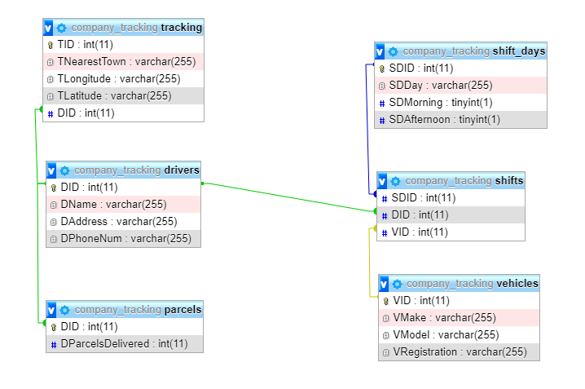After defining my entities, attributes and relationships, I was able to create an ER diagram for my database. This diagram can be seen here

# Queries

The solution I came up with had multiple queries. The first requirements for queries was to supply the location of a vehicle and its driver. This is addressed by the following query and its output:

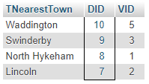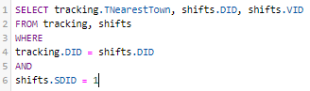

This query is expected to ouput the nearest town relating to the co-ordinates recorded as well as the Driver ID and the Vehicle ID. It is also expected to output 4 results being the locations of the driver on a Monday morning shift. This is because we have specified that shifts.SDID has to be equal to 1 which is the ID for a shift on Monday in the morning as well as specifying that the DID on tracking has to be equal to the DID on shifts. The querie’s output was as expected.

The next query requirement was to output the number of parcel delivered by any specific driver during a day’s work. The following query addresses this:



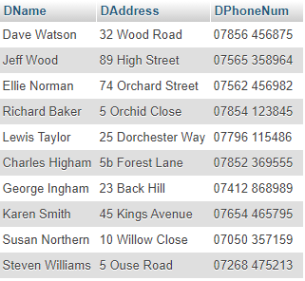This Query outputs the DID 1 as well as the number of parcels delivered being 20 in this case. This is the output that was expected and it outputs the following because we have specified that we want DID to have to be equal to 1 which will only output the value for driver 1. This could be changed or expanded to ouput all drivers or drivers 5 and 6 for instance.

The second to last query requirement was a query listing all drivers. This was addressed by this query

This was expected to output all the drivers as there is no ‘WHERE’ statement to specify any additional requirements. As expected this query does output all 10 drivers in the driver table.

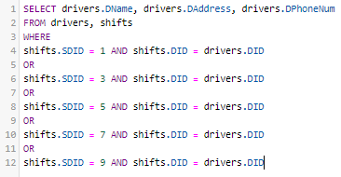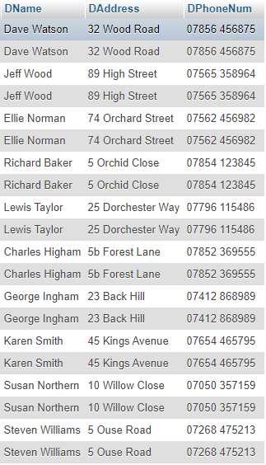The last query was required to output a lisitng of all drivers that had driven on a morning shift. This was addressed by the following two queries

This first query was expected to output all the drivers that had a morning shift including theire name, address and number. However It outputs all the drivers twice along with their address and their phone number which is not the output that was expected.

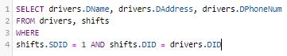The second query for the requirement is the following along with its output:

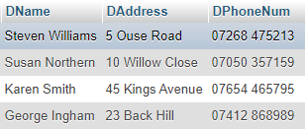This Query was expected to output each driver that has a Monday morning shift. This is because the SDID in enitity Shifts has to be 1 which corresponds to a Monday morning shift as well as requiring the Driver ID in shifts to be equal to the one in drivers. This query ouputs the expected values.